## Sensitivity Analysis

In lecture 1, we assume that values of all model coefficients are known with certainty but such certainty rarely exists.

Approaches

* Solver also produces sensitivity reports
* Change the data and re-solve the model

Sensitivity Report shows

* 目标函数系数可以在不改变最优解的情况下改变的量
* 约束资源(constrained resources)变化对最优值的影响
* 决策变量(decision variables)变化对最优目标函数值的影响
* 约束系数(constraint coefficients)变化会对最优解产生影响

## General Form of a Linear Programming (LP) Problem

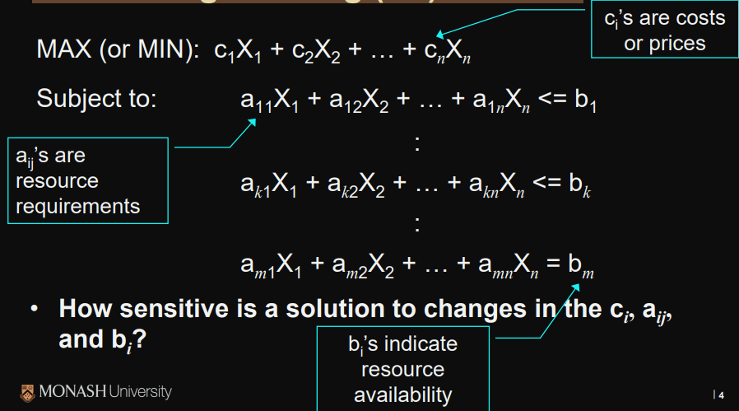

## Answer Report

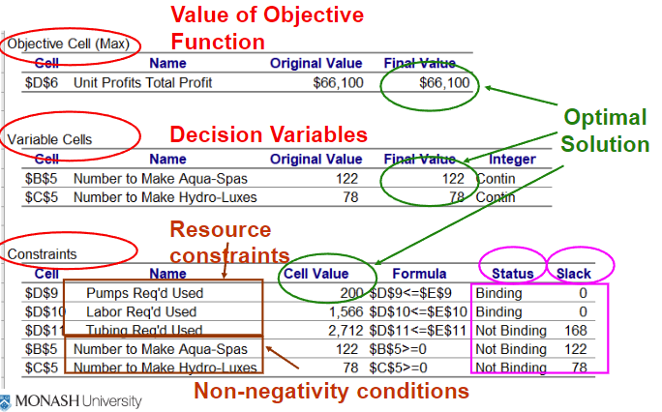

Section 1: Final value of opti mal solution (obj.function).

Section 2: Final values of decision variables.

Section 3: How much of each resource is used.

**Status: Not binding means not full used**

**Slack: The quantity that not used**

## Sensitivity Report

variable cells section

* What happens when we change the values of the coefficients in the objective function
* What happens if we include variables which are not part of the optimal solution

constraints section

* What happens to the value of the objective function if we increase (or decrease) available resources
* “Allowable Increase” and Allowable Decrease” the amounts by which an objective function coefficient can change without changing the optimal solution

## Constraint RHS Values

Shadow price of a constraint indicates the amount by which the objective function value changes given a unit increase in the RHS value of the constraint, assuming all other coefficients remain constant.

## Shadow prices

* Shadow prices of a resource you are currently paying for between which you would be willing to pay to get an additional unit of that resource
* Shadow prices holds if RHS value of constraint falls within allowable Increase or Decrease values.
* Resources in excess supply (not blinding) have a shadow price (or marginal value) of zero
* 影子价格越大表示这种资源相对紧缺，反之影子价格越小表示这种资源相对不紧缺。影子价格是0就表示这种资源处于过剩状态
* 调整一个约束右边常数项时候，目标函数的变化率
* 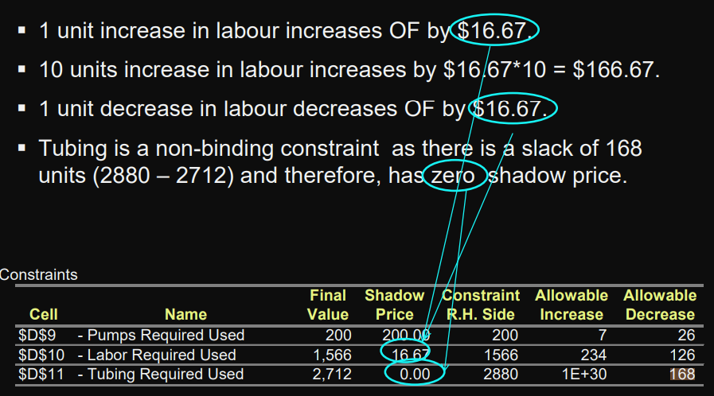

## Reduced Costs

